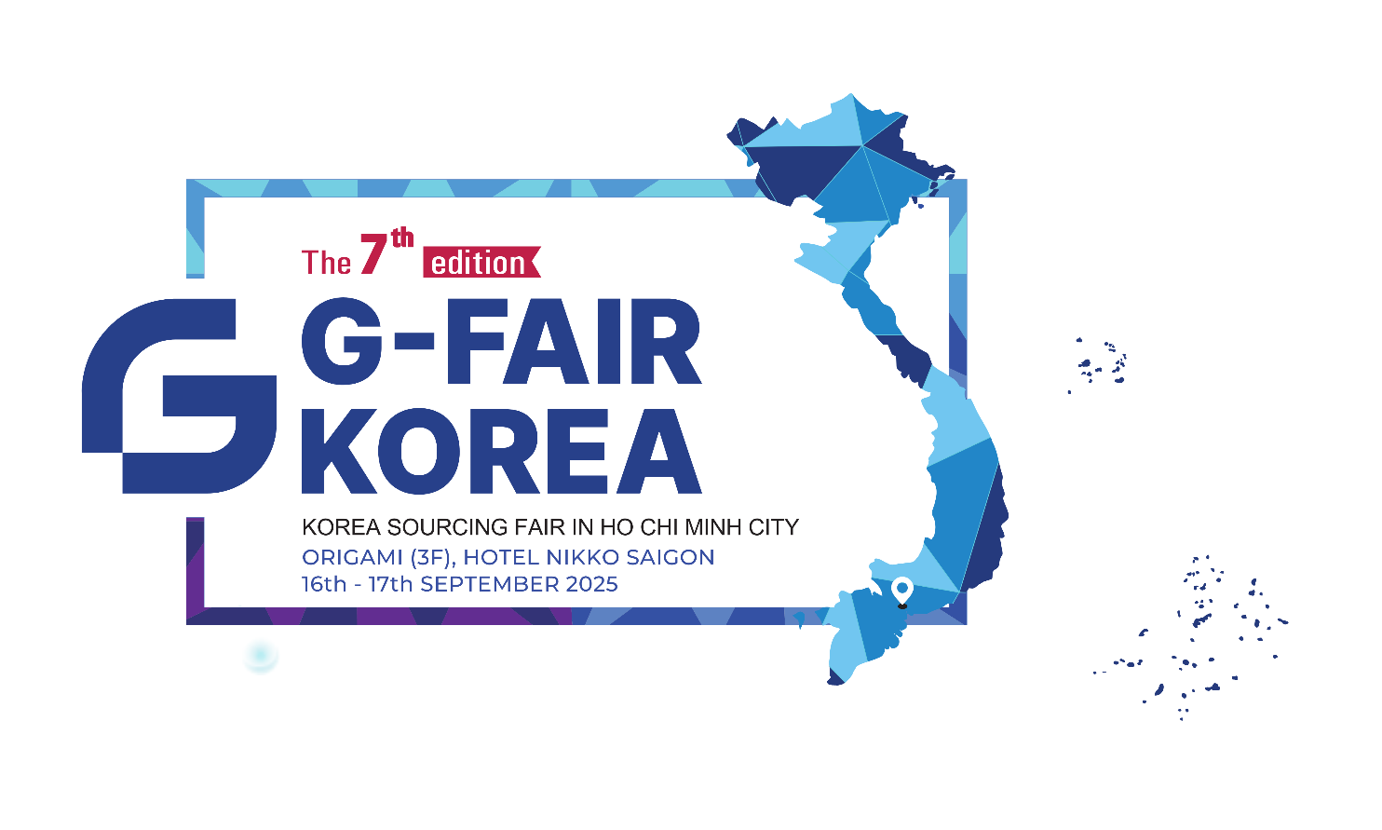
Dear Ladies and Gentlemen,
We would like to cordially invite you to attend the exhibition
‘G-FAIR HOCHIMINH 2025’.
Please inform us of participant details, the participation time and the category you are interested in. The details are listed in the next page.
We are looking forward to seeing you at the exhibition.

Truly Yours,
Kim Dong Yeong
Director & CEO
GBC Hochiminh
(S&H Business Solutions Co., Ltd.)


TIME
09:00 AM - 05:00 PM, 16th - 17th September, 2025
VENUE
Hotel Nikko Saigon
3rd Floor, Origami Ballroom
235 Nguyen Van Cu, Cau Ong Lanh Ward, HCMC
Tel: 028-3925-7777
Google Maps
ORGANIZER
Cong Ty TNHH MTV Son Phat
Gyeonggi Business Center Ho Chi Minh
(Cong Ty TNHH Giai Phap Kinh Doanh S&H)
Gyeonggido Business & Science Accelerator
CONTACT POINT
Manager & PIC Name:
E-mail:
Office:
Mobile:
Code Number:
EXHIBIT ITEMS
- Zone A: Consumer Products & Food
- Zone B: Industrial & Medical Products
- Zone C: Electronics & Electrical Products
- Zone D: Beauty & Health
VISITOR ONLINE PRE-REGISTRATION
https://forms.gle/mz79GX4PofgQgjyr7

or check out the participating companies here
Click To Register Now

